STANDARD OPERATING PROCEDURE

Purpose
A Standard Operating Procedure (SOP) is a set of written instructions that document all steps of a process or activity. The SOP is crucial since it helps eliminate inconsistencies and errors, and helps ensure that standards are met. A SOP should be written in a clear and concise manner.
How to Use
1. Begin with the goal in mind

- Name the process or activity in the organization that you want to document. What is the specific scope of this process? Who are the users?

2. Ask for input

- Gather the team and ask them how they think the job should be done, as detailed as possible. These are the people who are following the SOP, so you want to ensure that it makes sense to them and that all the necessary tasks are included.
- Record the steps using a process map on a flip chart so all team members can view and agree on it. A guideline on how to create a process map is also included on the Seeding Success website.

3. Identify the audience for the SOP

A SOP is a working document and guideline. Therefore, the writing should be from the practical perspectives of those who are going to adhere to the SOP. Thinking ahead about the users will help you draft the SOP in their language.

Some questions you can ask about your audience:

- What is their prior knowledge and experience? Are they already familiar with the organization, the procedures, and the terminologies?
- What are their language skills? Maybe your audience does not speak your native language. Therefore, the language should be as simple and straightforward as possible.
- Are there new employees? Your SOP documents need to be very detailed but concise for these new employees.
- What is the size of your audience? Will multiple people in different roles be reading the document? If yes, clearly define who, or what role, performs each task.

4. Write the SOP

Use this SOP template to create the first draft of your SOP.

5. Test, edit, repeat

Send the first draft of your SOP to your team and all relevant stakeholders, especially those who need to use the SOP on their jobs. Have the stakeholders test the process indicated in the SOP to ensure it can be easily followed and the process can be completed successfully. Revise the SOP (multiple times if needed) until all stakeholders approve the SOP.

SOP Name/Title
Document Storage Location/Source |  | Document No:
SOP Originator | Approving Position | Effective Date
Name | Name | Last Edited Date
Signature | Signature | Other:

- Purpose

A brief discussion of why the SOP exists

- Scope

What procedures will this SOP cover? Who will be affected by this SOP Procedure? Are there any limitations or areas where this SOP does not apply?

- Responsibilities

Who is listed in this SOP and what are they required to do?

- Materials

Are there any resources needed to complete this process?

- Related Documents

Any document mentioned in the SOP or needed to complete the steps in the SOP should be listed here.

- Definitions

What words, phrases, or titles are used in this procedure that readers may not understand?

- Procedures

Make a rough flowchart, which provides you with a visual representation of the whole process before you break it up into procedures of steps of a process.
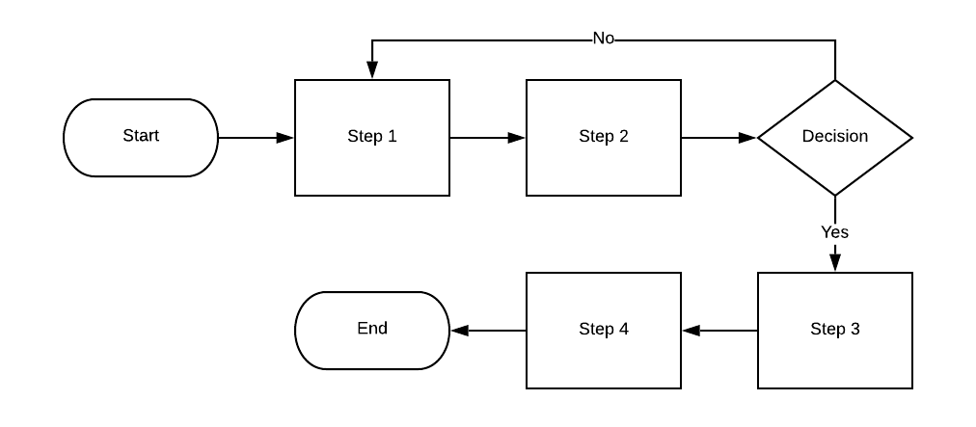

Start steps with action verbs.
Who performs the first step of the process and what do they do? Are any forms used?
Who performs the second step of the process and what do they do? Are any forms used?

Step | Action | Responsible
1
2
3

- Process Metrics
What measures communicate the process is working?

EXAMPLE STANDARD OPERATING PROCEDURE
– Baking a Cake

SOP Name/Title: Baking a chocolate cake
Document Storage Location/Source: Main Kitchen Counter |  | Document No: 1
SOP Originator: Baker | Approving Position: Head Chef | Effective Date: April 4, 2020
Name: Josie | Name: Malinda | Last Edited Date: April 3, 2020
Signature: Josie | Signature: Malinda | Other:

- Purpose

Ensure the consistent quality of chocolate cakes.

- Scope
This SOP will cover all steps of baking a chocolate cake. All bakers need to follow this SOP for every chocolate cake order.
- Responsibilities
- Baking a cake: Bakers

- Materials
- 3 cups all-purpose flour
- 3 cups granulated sugar
- 1 1/2 cups unsweetened cocoa powder
- 1 tablespoon baking soda
- 1 1/2 teaspoons baking powder
- 1 1/2 teaspoons salt
- 4 large eggs
- 1 1/2 cups buttermilk
- 1 1/2 cups warm water
- 1/2 cup vegetable oil
- 2 teaspoons vanilla extract

- Related Documents
- Use the “Ingredient Checklist” to ensure all ingredients are ready before baking.

- Definitions
- Granulated sugar: Granulated sugar is also sometimes known as white sugar, or “regular” sugar. Granulated sugar has had all of the naturally present molasses refined out of it.

- Procedures
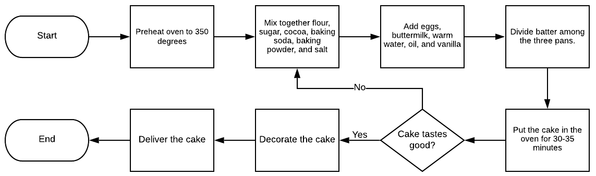

Step | Action | Responsible
1 | Preheat oven to 350 degrees | Baker’s assistant
2 | Mix together flour, sugar, cocoa, baking soda, baking powder, and salt in a stand mixer using a low speed until combined | Baker
3 | Add eggs, buttermilk, warm water, oil, and vanilla. Beat on a medium speed until smooth. This should take just a couple of minutes | Baker
4 | Divide batter among the three pans | Baker
5 | Bake for 30-35 minutes until a toothpick inserted into the center comes out clean | Baker’s assistant
6 | Cool on wire racks for 15 minutes and then turn out the cakes onto the racks and allow to cool completely | Baker’s assistant
7 | Taste cake | Baker
8 | Decorate the cake | Baker
9 | Deliver cake | Baker’s assistant

- Process Metrics
The cake meets the visual and quality standards of the head chef (below photo).
