SWOT ANALYSIS
Purpose
SWOT, which stands for Strength, Weakness, Opportunities, and Threat, is an analysis to evaluate a project, a process, or an entire organization. It ensures that the project, process, or organization remains updated with external opportunities and risks. For instance, it helps the organization:
- Define the internal strengths to be further maintained or developed.
- Define the internal weaknesses to be adapted or addressed.
- Define the external opportunities that the organization can leverage.
- Define the external threats that the organization can be prepared for or find ways to minimize the risks.
The SWOT analysis can be developed after deciding on the project/organization’s objectives or before finalizing a strategy. The SWOT analysis should be revisited whenever changes occur in the environment, such as changes in legislation, policies, and the organizations’ objectives.

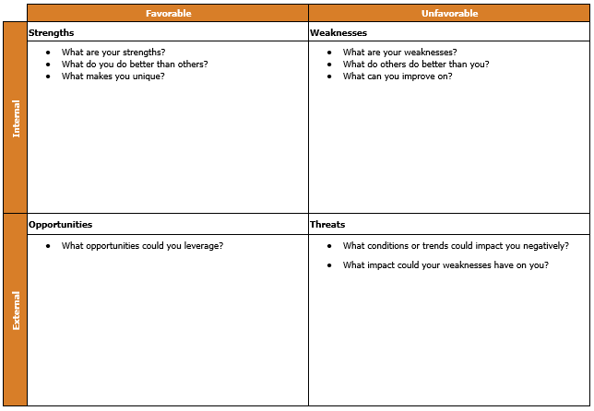
How to Facilitate
1. Identify the stakeholders
Gather the stakeholders for a brainstorming session. The stakeholders can vary from subject matter experts, operating team members, to partners who have insights into the questions asked in the SWOT.
2. Identify the objectives
Prepare and distribute the documents that identify the goals or the vision of the project, process, or organization.
3. Understand the template
Explain each category (Strength, Weakness, Opportunity, and Threat) with questions included in the template (below). Remember that Strengths and Weaknesses are for internal operations, while Opportunity and Threat are for the external market/sector.

4. Write down all suggestions
Collect and document answers provided by participants for each category (Strength, Weakness, Opportunity, and Threat). Avoid judging the insights. The whole group will consolidate all insights later.
5. Pick top ten
Have participants vote on the top ten insights in each category and consolidate the results. In the event there are too many people, you can group participants based on expertise. Then, guide each group to discuss and provide the top ten insights to the rest of the participants. All groups will then vote on the final top 10 insights.
6. Revise the operational plans based on the top 10 insights from the SWOT analysis
- Create an action plan that can combine internal strengths and external opportunities. These are the areas where the organization has natural advantages and should be marked as high priority in planning and taking action.
- Create an action plan that can eliminate the internal weaknesses which are vulnerable to external threats. These are the areas where the organization has the biggest risk and should be a high priority in planning and taking action.

 | Favorable | Unfavorable
Internal | Strengths | Weaknesses
 | - What are your strengths?  - What do you do better than others?  - What makes you unique? | - What are your weaknesses?  - What do others do better than you?  - What can you improve on?
External | Opportunities | Threats
 | - What opportunities could you leverage? | - What conditions or trends could impact you negatively?  - What impact could your weaknesses have on you?

EXAMPLE SWOT ANALYSIS – Expanding Bakery Offerings

 | Favorable | Unfavorable
Internal | Strengths | Weaknesses
 | - What are your strengths? 20+ years of experience baking cakes for the local market. My specialties are chocolate and pound cakes.  - What do you do better than others? Hospitality towards customers.  - What makes you unique? Known brand for high quality cakes in the market. | - What are your weaknesses? Product type is limited: only cakes, donuts, and brownies. Each type has 5 different flavors.  - What do others do better than you? Creative marketing campaigns.  - What can you improve on? Reduce waste while making cakes.
External | Opportunities | Threats
 | - What opportunities could you leverage? More people prefer vegan cakes that do not use eggs or dairy products  Proposed action 1  Since I have extensive baking experience, a good reputation, and a known brand for high quality cakes in the local market (Internal Strength), I can capitalize on those qualities to add a new line of vegan cakes (Opportunities on the market) for customers. | - What conditions or trends could impact you negatively? New and similar bakeries opening up in the local city.  - What impact could your weaknesses have on you? At the moment, it is impossible to reach the customers who like more sophisticated baked goods (e.g. Boston cream pies or ice cream cakes)  Proposed action 2:  Seeing the heightened competition (External Threat) that comes from new and similar bakeries, I will cope by differentiating my shop and expanding my product offerings to more sophisticated cakes such as Boston cream pies or ice cream cakes. These new types also help me reach more premium customers. Currently, I only serve basic types of cakes (Weaknesses).

